# Detailed Project Report

E-commerce Dashboard

By Mayank Rai

## Project Description

The development of the internet was a big achievement for mankind. Great marvels were achievements by mankind by walking hand in hand with technology.

With the hectic life, we live it is very tiring to physically go to the shop and purchased the desired item. To physically buy something we have to manage our time, find a medium of transport, visit different shops for better prices, spend extra money on transport and food. But with e-commerce, all this can be done with just a few clicks and also with the comfort of you chilling at your home.

There is no doubt of what benefits e-commerce provides for B2B and B2C transactions. In this project, it was required to create design a sales dashboard to analyze the sales based on various product categories. The company wants to add user control for product categories, so users can select a category and can see the trend month-wise and product-wise accordingly.

## Contents

Detailed Project Report 1

Project Description 2

Contents 3

My Role and responsibility 4

Problem Statement and Task 5

Problem- 5

Tasks- 5

Findings 6

• Finding 1 6

• Finding 2 6

• Finding 3 6

• Finding 4 7

• Finding 5 7

• Finding 6 8

• Finding 7 8

Workings 9

Steps Taken – 9

Step 1 9

Step 2 9

Step 3 10

Step 4 11

Step 5 12

Step 6 12

Analysis 13

Conclusion 15

## My Role and responsibility

Fulfilling given roles and responsibilities is a factor that shows the effectiveness and efficiency of a person. If a person fulfils the roles or tasks given it shows that the person is reliable and can manage uncertainty.

My role was to create, build and design the dashboard with necessary and relevant data and I was responsible for any correction in the dashboard.

Maintaining the accuracy of the data presented in the dashboard is very important as on what is presented the management will decide the future of action.

## Problem Statement and Task

### Problem-

Sale is the backbone of every business. Good sales and marketing of a business build both revenue and the reputation of the company.

Mapping the audience or build a buyer persona helps to curate a business strategy for the target audience resulting in better output. Mapping also brings structure to the approach followed by the business. A structured way of functioning brings better direction towards achieving business goals.

To build a better understanding of sales and products. This project was initiated by covering all the necessary elements that affect the sales of the company.

### Tasks-

* Prepare a table of Sales and Profit month-wise in the working sheet.
* Prepare the sales table region-wise in the working sheet.
* Create User Control Combo box for Product Category.
* Create a Column Chart of the month-wise table and region-wise table.
* Link the table with the combo box.

## Findings

### Finding 1

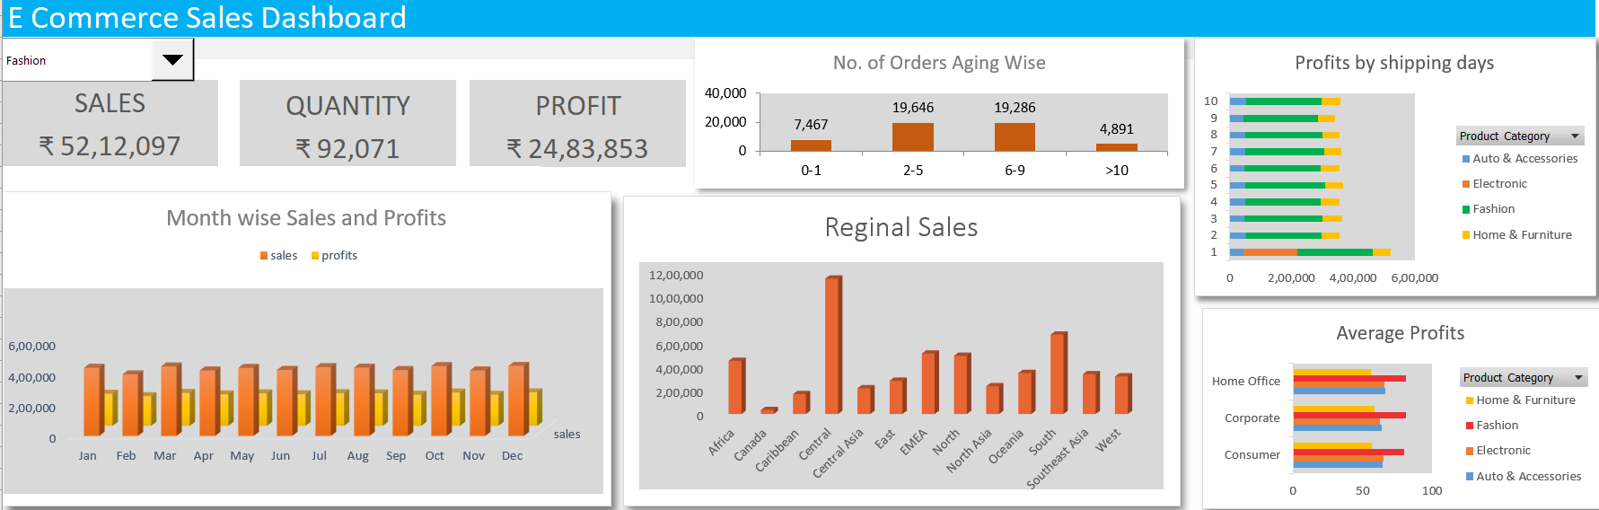

### Finding 2

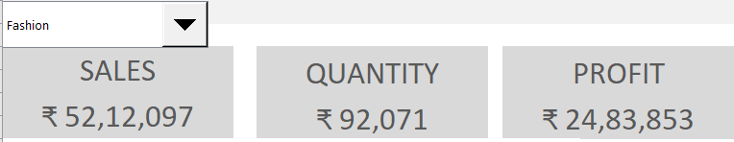

### Finding 3

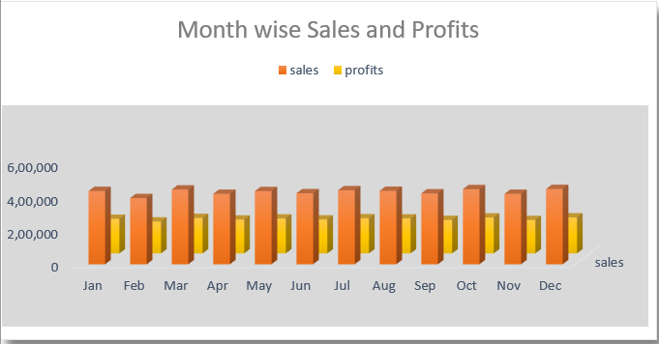

### Finding 4

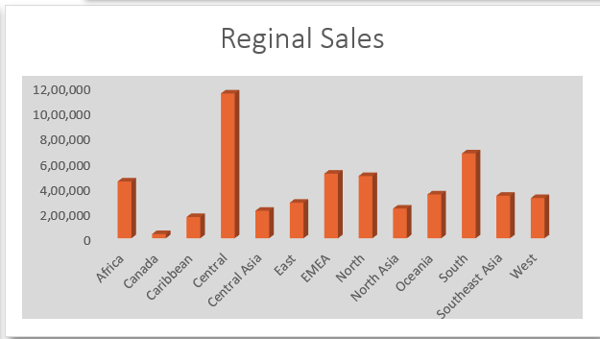

### Finding 5

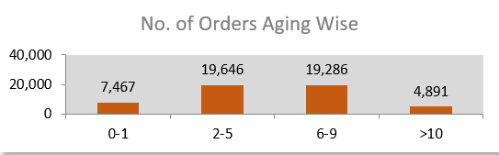

### Finding 6

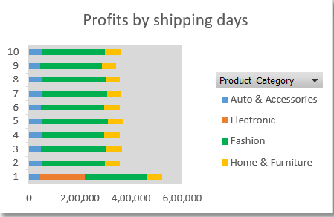

### Finding 7

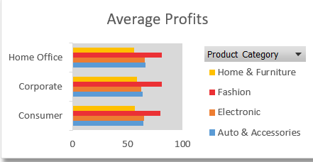

## Workings

Only the output is seen and admired by the people but the most important element is the input and measures required to build the result.

Working is the phase between planning and delivery of any product, project, etc and it is the empirical pillar for any activity. It is the phase where actual execution takes place with constant monitoring, reviewing, compilation, etc.

### Steps Taken –

### Step 1

To create a histogram, click the Data Tab, Under Analysis Group (Right Corner), Click Data Analysis.

Now, select Histogram and click ok. A histogram dialog box will appear.

In the histogram dialog box, first, click the Label’s Check box as we have labels in our data. After that, In the Input reference box select the range (“Sales Data!D1:D51291”) of our data and in the Bin Range Reference box select (“Workings!K3:K7”).

In the Output section, select range “Working!K13” for binning table, click Histogram check box and then ok.

### Step 2

* First, create a pivot table to get all the distinct product categories in one column.
* Insert Combo box for product category list in the Dashboard Sheet.
* Click Developer Tab > Under Controls Panel > Click Combo box and draw.
* Pass the Input Range and Cell for the Combo box.
* Right-click the country list Combo box > Click Format Control > Under Format
* Control Panel, Pass Input Range “Working!Q3:Q7” and Cell Link “Workings!R3” from the working sheet.

### Step 3

Now, write the Sumifs formula to calculate Sales, Quantity, and Profit in the Dashboard sheet.

**Enter the formula in cell A7 for Sales**:

* Enter the equal sign and then enter the function name and open parenthesis.
* Pass the first Argument is Sum_Range, select range ‘Sales Data’!$H$2:$H$1291, and then enter a comma.
* Now, pass the second argument Product Category column “criteria Range1” as ‘Sales Data’!$F$2:$F$1291, enter a comma
* Pass the third argument “criteria1” “Working!$R$5”, and enter a comma.

**Perform the same function to calculate the Quantity in Cell E7.**

* In E7, write the equal sign, and then enter the function name and open
* parenthesis.
* The first Argument is Sum_Range, select range ‘Sales Data’!I2:I1291, and then enter a comma.
* Now, pass the second argument Product Category column “criteria Range1” as
* ‘Sales Data’!F2:F1291, and enter a comma.
* Pass the third argument “criteria1” “$R$5,” and enter a comma.

**For-Profit**

* In I7, write the equal sign and then enter the function name and open
* parenthesis.
* The first Argument is Sum_Range, select range ‘Sales Data’!K2:K1291, and then enter a comma.
* Pass the second argument Product Category column “criteria Range1” as ‘Sales
* Data’!F2:F1291, and enter a comma.
* Now, pass the third argument “criteria1” “$R$5”, and enter a comma.

### Step 4

Now write the Sumifs formula to calculate the Sales and profit month-wise and sales region-wise.

Before that create a pivot table showing each month name.

Now enter the formula in cell D5:

* Enter the equal sign and then enter the function name and open parenthesis.
* The first Argument is Sum_Range, select range ‘Sales Data’!H2:H1291, and then enter a comma.
* Pass the second argument month column “criteria Range1” as ‘Sales Data’!U2:U1291,
* and enter a comma.
* Now, pass the third argument “criteria1” “$C$5,” and enter a comma.
* Pass the fourth argument as ‘Sales Data’!F2:F1291 product category column, and enter a comma.
* Pass the fifth argument as “$R$5.”
* Now, copy and paste the formula in Range D5:D16.

Enter the formula in cell E5:

* Enter Equal sign then enters function name and open parenthesis
* The first Argument is Sum_Range, select range ‘Sales Data’!K2:K1291, and then enter a comma.
* Now, pass the second argument month column “criteria Range1” as ‘Sales
* Data’!U2:U1291, and enter a comma.
* Pass the third argument “criteria1” “$C$5,” and enter a comma.
* Pass the fourth argument as Data!F2:F1291 product category column, and enter a comma.
* Enter the fifth argument as “$R$5.”
* Now, copy and paste the formula in Range E5:E16.

### Step 5

Write the equal sign and then enter the function name and open parenthesis.

* The first Argument is Sum_Range, select range ‘Sales Data’!H2:H1291, and then enter a comma.
* Pass the second argument region column “criteria Range1” as ‘Sales Data’!T2:T1291, and enter a comma.
* Now, pass the third argument “criteria1” “$G$5,” and enter a comma.
* Pass, the fourth argument as Data!F2:F1291 product category column, and enter a comma.
* Pass the fifth argument as “$R$5.”
* Now, copy and paste the formula in Range G5:G16.

### Step 6

Create Column Chart

Now, create the column chart for both region-wise and month-wise tables.

Select table (C5:E16), click insert tab > under Charts Panel > Insert column chart.

Cut and Paste the chart in the Dashboard Sheet. Same for the region-wise sales table.

## Analysis

One of the key skills for any analyst is to derive information from complex data and present the insights in a simple but meaningful way.

Q) Which product category has the highest sales?

A) Fashion category has the highest sales with ₹ 52,12,097 and maintaining a sales to cost ratio of 1.91.

Q) Why Fashion category has the highest sales?

A) It is demanding on various factors like –

* People want to be in trend and look good in social interactions.
* The frequency of purchase in fashion is higher. As people required variety of products in this category.
* The durability and usage factor of fashion products differ from other categories.

Q) What is the frequency of orders based on shipping days?

A) 0-1 : 7,467 orders

2-5 : 19,646 orders

6-9 : 19,286 orders

>10 : 4,891 orders

Q) Why does the 2-5 and 6-9 categories have higher orders but not 0-1?

A) Main reason why the 0-1 category does not have higher numbers of orders is that we charge extra an amount for 0-1 day delivery. The customer only uses this option when faced with quick delivery or has immediate use of the product.

Q) Why do we 6-9 and 2-5 shipping days have an almost equal number of orders?

A) People have adapted to the world of e-commerce and inside of going through tiring physically buying an item they are comfortable with the wait to receive items at their home.

Q) Why do we even have >10 shipping days?

A) Our area of operation covers various countries. So as the objective is of e-commerce is to let a person purchase anything from anywhere. It takes more days to deliver products to the customer as it depends on the factor of the distance between customer location and supplier, availability, supply chain, etc.

Q) What impact of shipping days on profit?

A) When shipping day is 1 we encounter a whopping of $5,21,097 sales while other days maintaining sales in the bracket of 3-4 million dollars.

Q) What are the reasons for the above phenomenon?

A) When shipping day is 1 the number of the orders is the maximum with over 7,000 with an average order of 153$.

Q) Which segment of products has a better performance based on profits?

A) Consumer segment has higher profits than its counterpart with profits of $19,15,712.

## Conclusion

The whole project was dedicated to sales and understand the elements that have an impact on sales. The degree of impact shipping days, product category, segments of product and region has on sales.

The fruit of hard work is what people look at ignoring the hard work. All the steps and techniques used to derive necessary insights for the project are also mentioned in detail. We discovered that the ‘Fashion’ product category has the highest sales ₹ 52,12,097 and maintaining a sales to cost ratio of 1.91.

We explored the reasons why the fashion product category has higher sales and found that factors like durability and social presence influence the sales. Then shipping days were studied to find the impact of shipping duration on profit and sales. In that, it was found that customers want immediate delivery of products that they purchased and electronic goods were only purchased in shipping days was in the category of 0-1 days. The performance of fashion in the product category and 0-1 days in shipping days is an outliner.

All the necessary elements and factors which are relevant to e-commerce sales were studied and visualized for easier understanding. With this dashboard, insights can be drawn easily and decisions or measures can be formed to improve performance.